# **How to Create an Assignment or Lab Using GitHub**

For Creating Assignment you have two steps:

* Create a template respository on [**https://github.com**](https://github.com)
* Create an assignment on [**https://classroom.github.com/**](https://classroom.github.com/)

**\*\*\*\*\*\*\*\*\*\*\*\*\*\*\*\*\*\*\*CREATING A TEMPLATE REPOSITORY\*\*\*\*\*\*\*\*\*\*\*\*\*\*\*\*\*\*\*\*\***

\*\*\*\*\*\*\*\*\*\*\*\*\*\*\*\*\*\*\*\*\*\*\*\***STEP 1 STARTED**\*\*\*\*\*\*\*\*\*\*\*\*\*\*\*\*\*\*\*\*\*\*\*\*\*\*\*\*\*

1. Sign up at [**https://github.com**](https://github.com)if you don't have one, then sign in with your GitHub account.

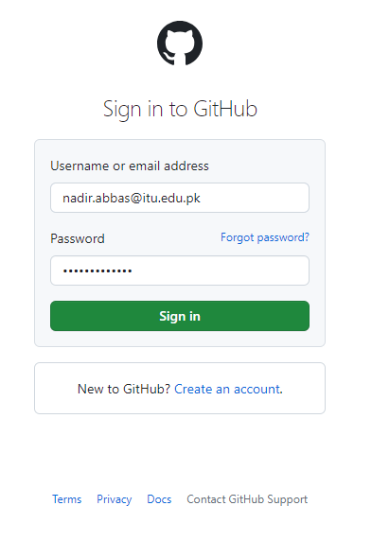

1. Select the **organization (e.g ITU-Lahore-CFP)** from the dropdown menu at top left corner of the page

1. Click on **View organization**

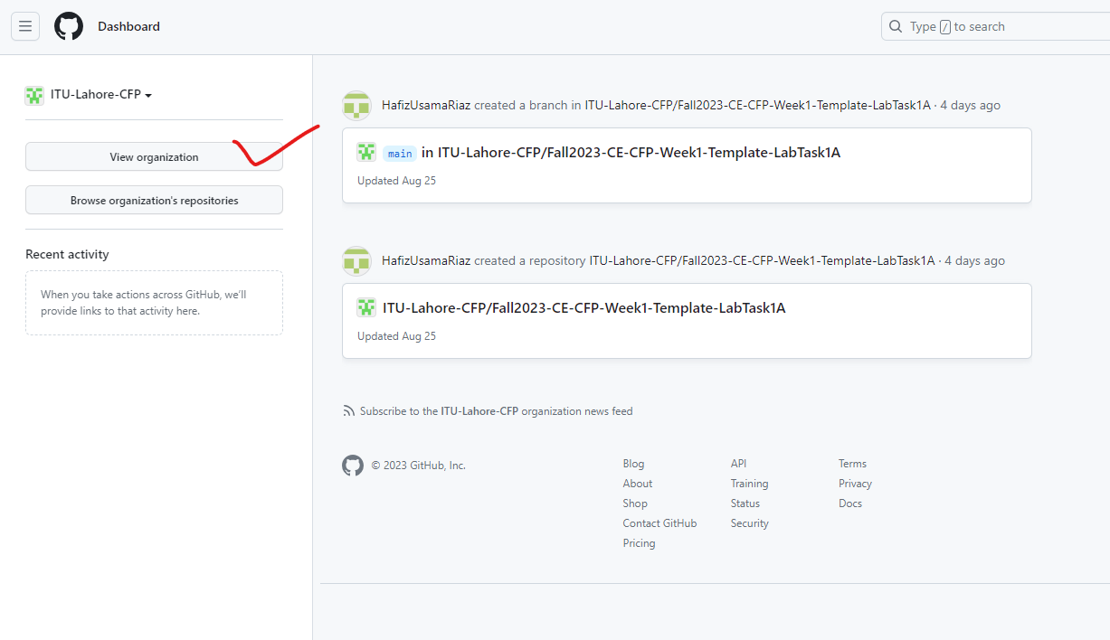

1. Click on **Repositories**

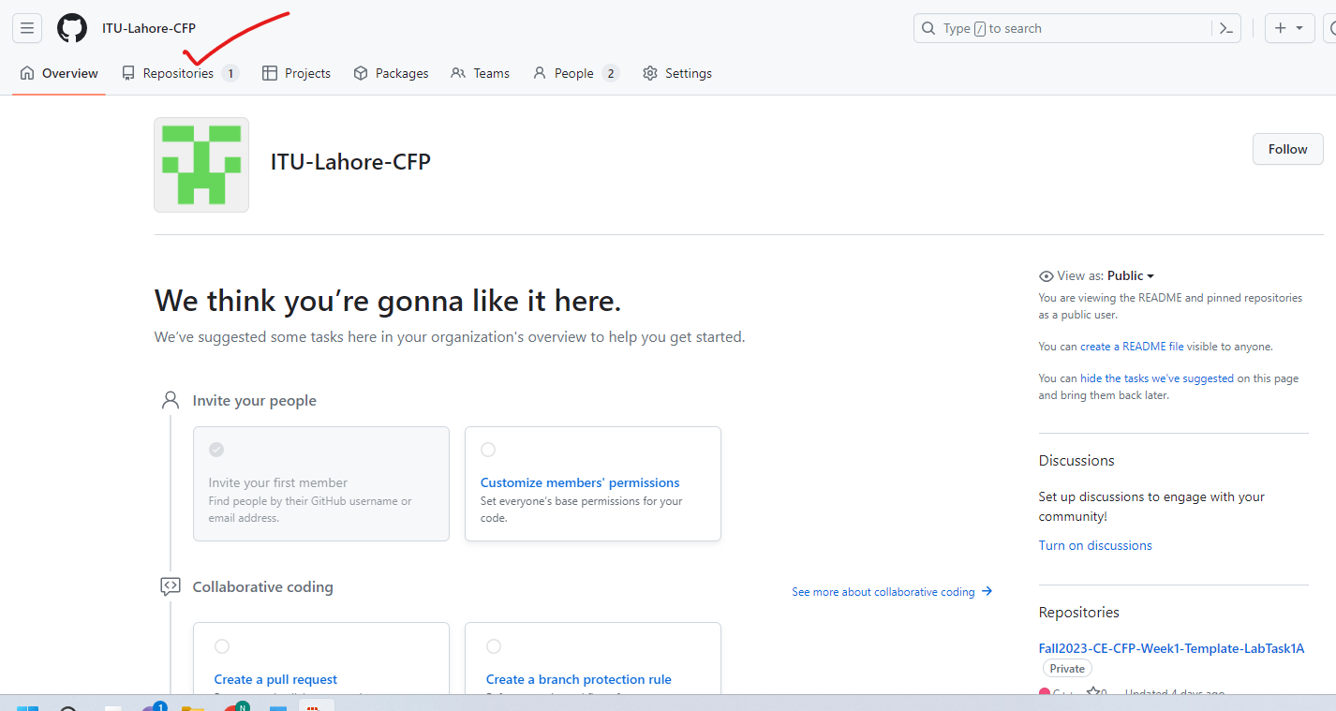

1. Click on **New repository**

1. Create a **new repository** (should be ***template repository***) give repository name in the formate e.g **Fall2023-EE-CFP-Week1-Template-LabTask1A** Then Click on **Create repository**

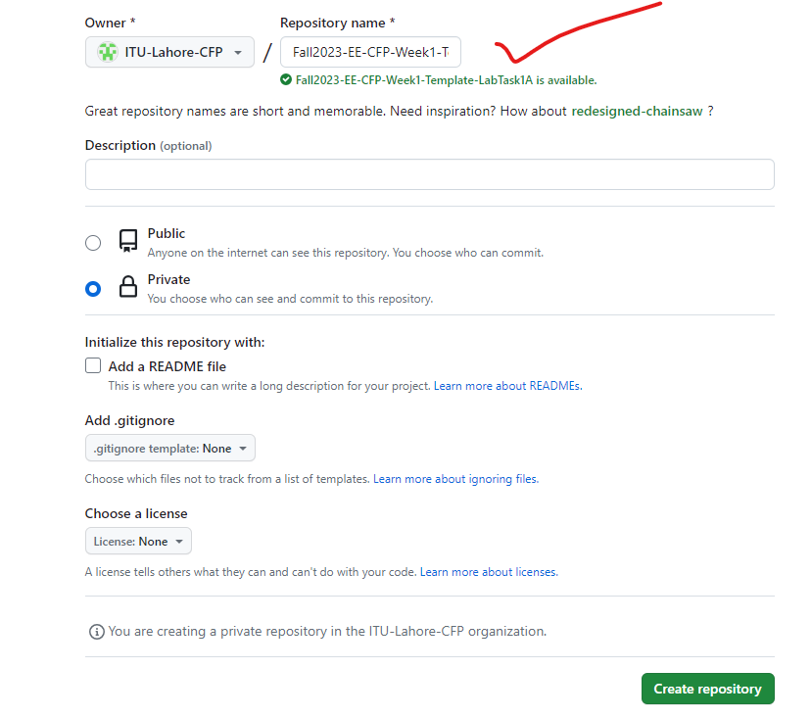

1. Click on the Code tab, then click on uploading an existing file

1. Drag files to add them to your repository

1. After adding files the repository then click on **Settings**

1. Check the the **Template repository**

**\*\*\*\*\*\*\*\*\*\*\*\*\*\*\*\*\*\*\*CREATING A TEMPLATE REPOSITORY\*\*\*\*\*\*\*\*\*\*\*\*\*\*\*\*\*\*\*\*\***

\*\*\*\*\*\*\*\*\*\*\*\*\*\*\*\*\*\*\*\*\*\*\*\***STEP 1 DONE**\*\*\*\*\*\*\*\*\*\*\*\*\*\*\*\*\*\*\*\*\*\*\*\*\*\*\*\*\*

**\*\*\*\*\*\*\*\*\*\*\*\*\*CREATING ASSIGNMENT ON GITHUB CLASSROOM\*\*\*\*\*\*\*\*\*\*\*\*\*\***

\*\*\*\*\*\*\*\*\*\*\*\*\*\*\*\*\*\*\*\*\*\*\*\***STEP 2 STARTED**\*\*\*\*\*\*\*\*\*\*\*\*\*\*\*\*\*\*\*\*\*\*\*\*\*\*\*\*\*

1. Sign in to [**https://classroom.github.com/**](https://classroom.github.com/)

1. Click on your respective classroom  
     
   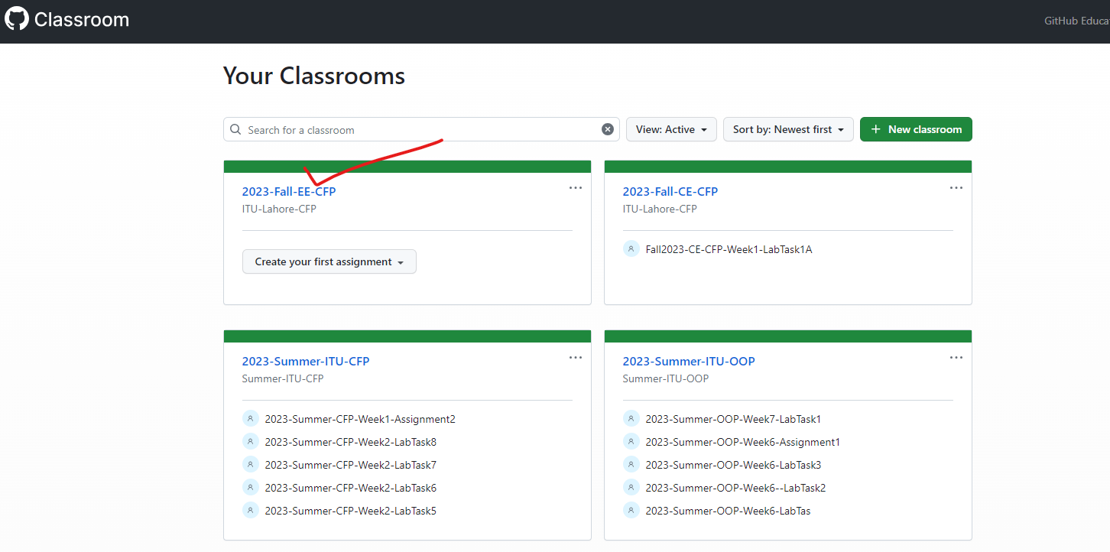
2. Click on **Create an assignment**

1. Give **Assignment title** e.g **Fall2023-EE-CFP-Week1-LabTask1A**, set the **Deadline**, and check the **cufoff date,** then click **Continue**

1. Add a **template repository** (**which you have created in STEP 1 and added files**), in this case it was **Fall2023-EE-CFP-Week1-Template-LabTask1A,** Click **Continue**

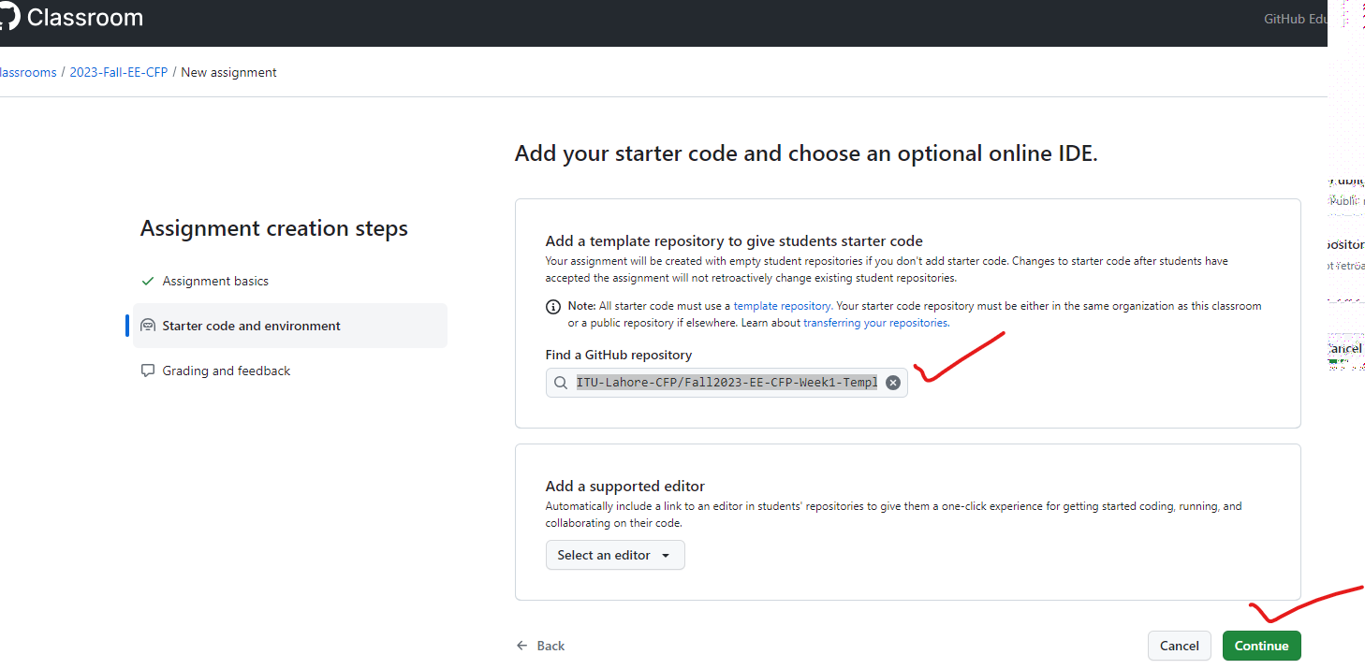

1. Click **Create assignment**

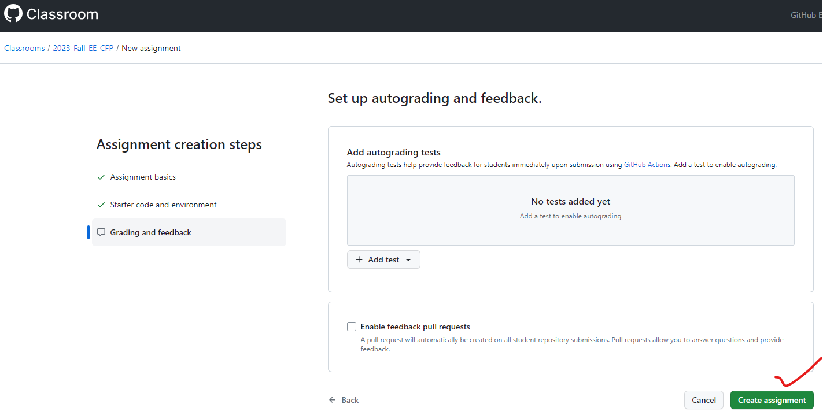

1. Copy the **assignment URL** (Your assignment is now prepared) and distribute the invitation link to students using Google Classroom.

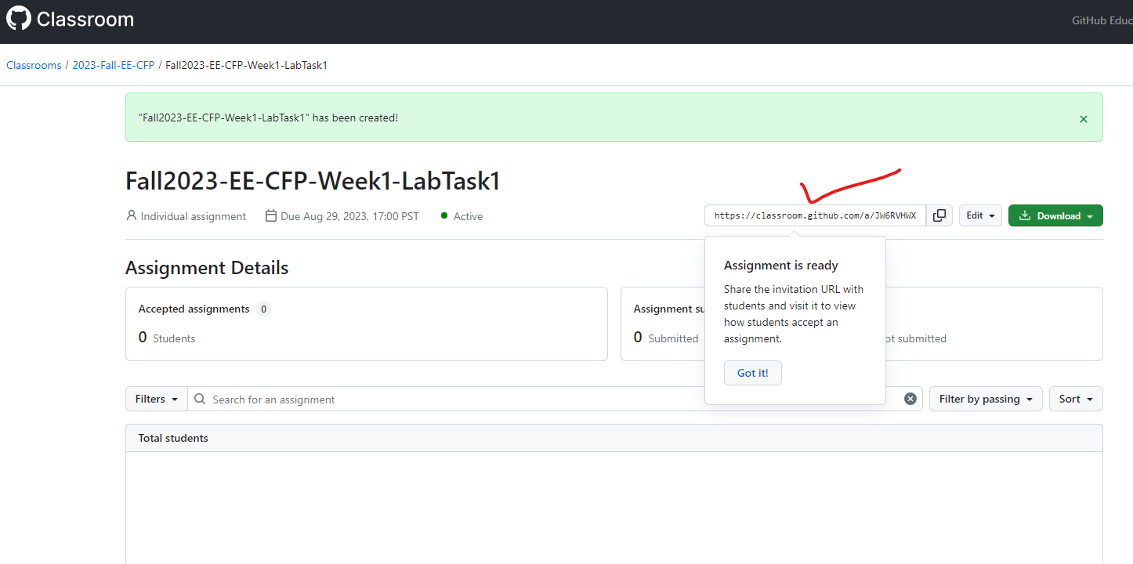

**\*\*\*\*\*\*\*\*\*\*\*\*\*CREATING ASSIGNMENT ON GITHUB CLASSROOM\*\*\*\*\*\*\*\*\*\*\*\*\*\***

\*\*\*\*\*\*\*\*\*\*\*\*\*\*\*\*\*\*\*\*\*\*\*\***STEP 2 DONE**\*\*\*\*\*\*\*\*\*\*\*\*\*\*\*\*\*\*\*\*\*\*\*\*\*\*\*\*\*

**\*\*\*\*\*\*\*\*\*\*\*\*\*CREATING ASSIGNMENT ON GOOGLE CLASSROOM\*\*\*\*\*\*\*\*\*\*\*\*\*\***

\*\*\*\*\*\*\*\*\*\*\*\*\*\*\*\*\*\*\*\*\*\*\*\***STEP 3 STARTED**\*\*\*\*\*\*\*\*\*\*\*\*\*\*\*\*\*\*\*\*\*\*\*\*\*\*\*\*\*

1. Sign in to [**https://classroom.google.com/**](https://classroom.google.com/)
2. Go to **Classwork** and create an **assignment**

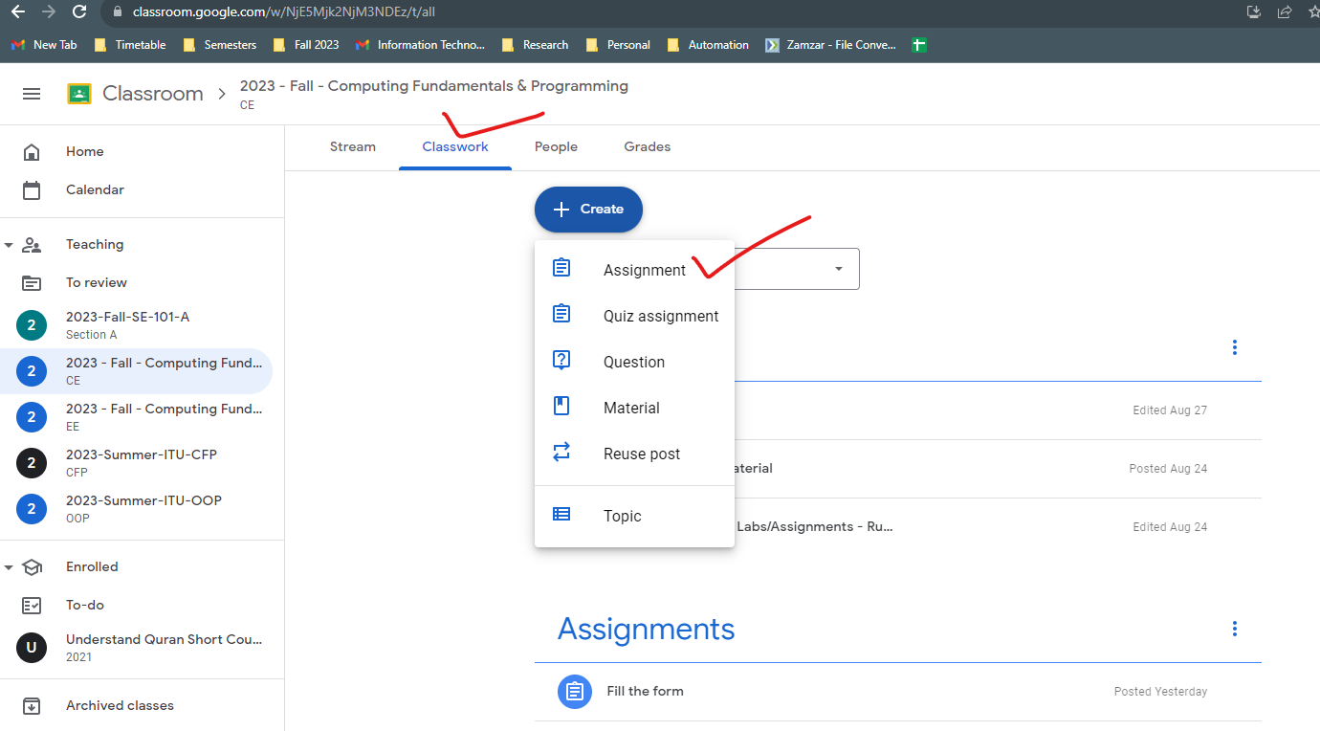

1. Provide the **assignment title** and include the **link** to the GitHub Classroom URL acquired in **STEP 2**.

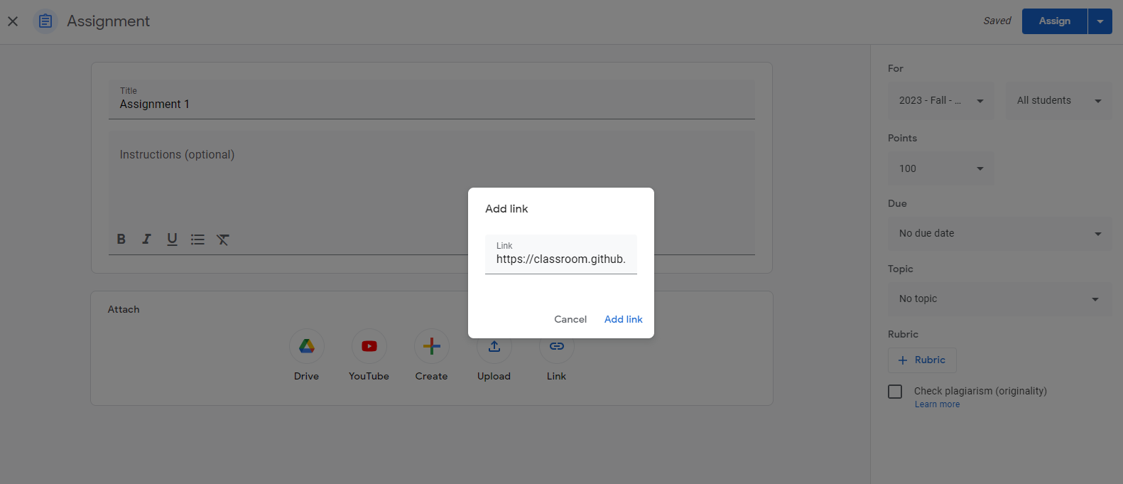

1. After configuring the **due date** and other necessary **settings**, your assignment is ready to be **shared** and **published**. Additionally, you have the option to **save it as a draft** if needed

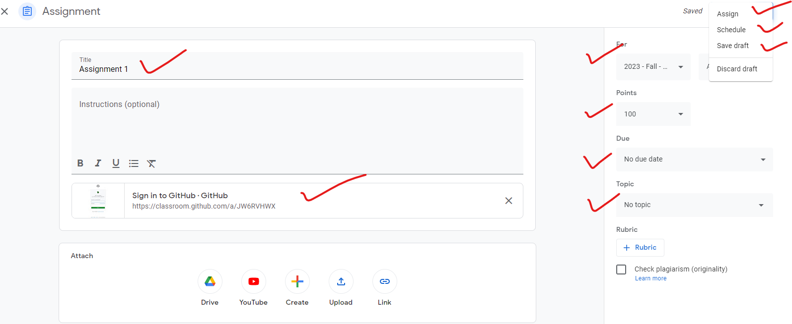

**\*\*\*\*\*\*\*\*\*\*\*\*\*CREATING ASSIGNMENT ON GOOGLE CLASSROOM\*\*\*\*\*\*\*\*\*\*\*\*\*\***

\*\*\*\*\*\*\*\*\*\*\*\*\*\*\*\*\*\*\*\*\*\*\*\***STEP 3 DONE**\*\*\*\*\*\*\*\*\*\*\*\*\*\*\*\*\*\*\*\*\*\*\*\*\*\*\*\*\*